Immigration Services and Advice
You may not be aware that Power Legal has recently added to its service offerings, with Annette becoming a Registered Migration Agent.
Anybody who provides immigration advice or assistance is legally required to be registered with the Office of the Migration Agents Registration Authority and to have a sound knowledge of migration law and process.
Complementing her legal experience of over 35 years, Annette is now able to assist in any aspect of migration law, including:
- Skilled visas
- Family visas
- Partner visas
- Student visas
- Business and investment visas
When applying for a visa it is important to identify the most suitable pathway and visa type for your circumstances. Using a migration agent can assist with this process and help you navigate the complex laws and regulations to get your visa application underway.
We look forward to advising and assisting our clients in all areas of migration law.

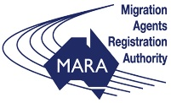
Registered Migration Agent MARN 1796016

